

A Major Project Report on

# “Grain Dryer”

## Bachelor of Engineering in

Mechanical Engineering

## Submitted by

|  |  |
| --- | --- |
| Shakainah Achary | 01FE19BME077 |

Under the Guidance of

*Prof. P.P.Revankar*



## 2021-2022

**School of Mechanical Engineering**

## K.L.E Technological University, Vidyanagar, Hubballi 580031



CERTIFICATE

This is to certify that Senior Design Project 2022-23 entitled **“Grain Dryer”** submitted by **Team-M17 to** the **KLE Technological University**, Hubli-580031, towards partial fulfilment for the award of the degree of Bachelor of Engineering is a bona-fide record of work carried out by him/her under our supervision. The contents of the project report, in full or in parts, have not been submitted to any other institute or university for award of any degree or diploma.

|  |  |
| --- | --- |
| Prof. P.P.Revankar | Dr. B. B. Kotturshettar |
| **Guide** | **Head of School** |



## ACKNOWLEDGEMENT

The successful completion of any task would be incomplete without mentioning the people who made it possible and whose guidance and encouragement has made our efforts successful.

At the outset, we would like to express our deep sense of gratitude for our guide **Prof.P.P.Revankar** for making this project report successful through their invaluable guidance at every stage of the project report.

We also thank **Dr. B. B. Kotturshettar** for his encouragement in undertaking the task of this project.

We express our sincere regard and gratitude to our project co-ordinators **Prof.P.P.Revankar** and course mentors **Prof R.S.Hosmath, Prof Suresh.H.K,** School of Mechanical Engineering, KLE Tech,, Hubli

We are also thankful to all faculty members of the Mechanical Engineering Department of KLE Technological University, for helping us directly or indirectly in different stages of our project work.

## Student signature

**(Team-M17)**



**Table of Contents:**

|  |  |
| --- | --- |
| **1. Abstract** |  |
| 1.1 Problem Statement | **5** |
| **2. Studying and exploring competitive products** |  |
| 2.1 Patent search | **7** |
| **3. Design Specifications** |  |
| 3.1 Objectives | **11** |
| 3.2 Constraints | **11** |
| 3.3 Functions | **11** |
| 3.4 Design Specifications | **12** |
| **4. Concept generation** |  |
| 4.1 Generating design alternatives | **12** |
| **5. Design** |  |
| 5.1 3D Model | **17** |
| 5.2 Assembly models/ Exploded view | **23** |
| 5.3 2D drawing | **24** |
| 5.4 Design Calculations | **26** |
| 5.5 Bill of Materials | **28** |
| **6. Structural Analysis and Mechanisms** |  |
| 6.1 Type of FEM Analysis and Justification | **32** |
| 6.2 FE Analysis Details | **32** |
| **7. Conclusions & Future Scope** |  |
| 7.1 Results and Discussions | **33** |
| 7.2 Conclusion | **33** |
| **8. Reference** |  |
| 8.1 Published papers and Authors | **34** |



# Abstract

According to the census 2011,54.6% of India’s population depends on agriculture for their livelihood and it produces about 260 million tonnes of food grains per year. In olden days food grains were dried in open sun but in this method, energy is improperly utilised and it takes a longer time for drying. This leads to compromise in food quality and needs continuous observation.

Fluidized bed drying is well known to eradicate this problem. In this project, Fluidized bed dryer (FBD) has been used widely for drying Paddy due to its many advantages, including high drying rate due to an excellent gas-solid contact, high thermal efficiency, relatively low cost of operation etc . In fluidized bed drying, hot air is forced through a blower, which works on solar panels, into bed at a sufficiently high velocity to overcome the gravitational forces on the products.

This project aims to design a grain dryer with available methods using solar energy without much investment required.

# Problem Statement

Grains are routinely seen dumped in villages and major cities during the peak of harvest; therefore it is necessary that these grains are properly dried and stored to ensure availability and wholesomeness throughout the year, so designing a suitable machine to dry grain to specified moisture level, so that the shelf life of grain can be increased.



## Product Benchmarking

|  |  |  |
| --- | --- | --- |
| **Products (Images or name)** | **Specifications** | **Cost** |
| Stainless Steel Grain Dryer Machine  **Stainless Steel Grain Dryer** | Material: Stainless Steel Automation Grade: Semi-Automatic Type of Flow: Contra-flow  Type of atomization: Pressure Batch Capacity: 12 Ton | Rs 5,50,000 |
| 5 Hp Mild Steel Multigrain Drying Machine, SS 304, Single Phase  **Multigrain Drying Machine** | Capacity: 200kg/hrs Mode: Automatic Electricity : Single phase Material: Mild steel | Rs 75,000 |
| Grain Dryer  Grain Dryer | Capacity: 3 Ton per chamber Material: Mild steel  Blower temperature: 60-70 degree C | Rs 10,50,000 |
| Mild Steel Powder Coated 4HP Automatic Dal Grain Dryer, Three Phase, 1000 kg/Hour  Automatic Dal Grain Dryer | Capacity: 1000kg/hour Material: Mild steel Operation mode: Automatic | Rs 1,40,000 |



**2.2 Patent search**

## CFD analysis of solar grain dryer [1]

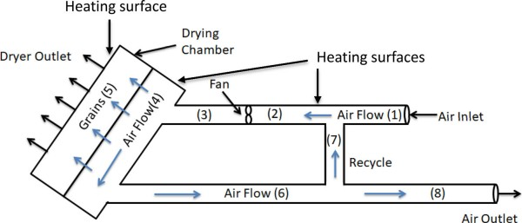

Fig 1. Diagram shows solar grain dryer

Most energy saving approaches for convective drying are based on heat recovery from the exhaust stream, because a significant amount of heat used in drying appears in the exhaust stream. Drying grain in the open sun is being used even today. In the open sun drying technique, solar energy isn't properly utilised, and makes the drying process longer and hard to dry, which leads to product quality being hampered. Also, space utilisation using such a technique increases floor space, and needs continuous observation for drying to ward off birds or pets etc, and results in depreciation of quality standards. In the said work, a compact solar grain dryer design and optimised for higher energy efficiency is being proposed. Various designs were tested using CFD analysis for their performance. To make the grain dryer energy further efficient, a certain amount of the hot air was recirculated, and simulations were performed to optimise the sizing and location of the solar fan. Several parameters that determine the overall performance were considered, such as air flow rate, pressure and temperature. An orifice was given at the inlet of the pipe to increase the quantity and quality of recycled air. This orifice was tested for various diameters to obtain optimum results and increase the efficiency using CFD analysis. Furthermore, two dryer design was proposed, with fins and other without fins.

## The state of the art in energy saving techniques for garment/textile drying [2]

Drying is a process that exists everywhere in a wide range of applications and even in industries, inclusive of residential and commercial textile drying, chemical processing, and the pharmaceutical industry. Drying using thermal heat is very much energy consuming

due high specific heat capacity of water and high latent heat of evaporation (>2000 kJ kg−1)

of water vapour.



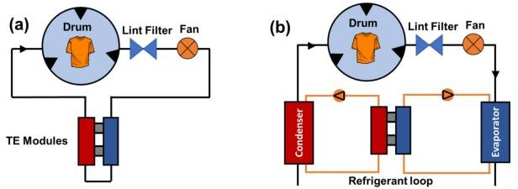

Fig 8. Diagram of (a) thermoelectric dryer (TED) & (b) thermoelectric heat pump dryer (TEHPD).

Various techniques have been attempted to minimise energy consumption in different dryers. This published paper focuses on the theory of drying and the underlying principles of mass, species, and heat transfer phenomenon, and helps to identify the most energy- consuming step in the given process, assessment of this has potential for energy savings, and various energy saving methods considered in the study.

## Numerical simulation of heat and mass transfer during sublimation drying of porcine aorta [3]

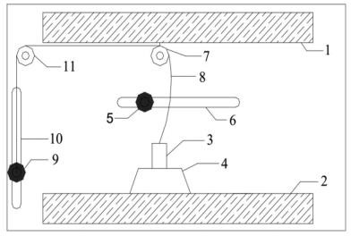Freeze-drying is a method effective for aortal preservation. There has been studies in this field of freeze drying for aortal preservation. This study employed various contactless weighing devices used to monitor freeze-drying processes. Heat transfer properties was calculated for aortic preservation, and this model was used to analyse heat and mass transfer in the frozen grain. It was observed that there was certain amount of heat flux in the frozen layer of the grain, which provided sublimation heat for the sublimation interface. Using theoretical calculation, the vapour diffusion coefficient was obtained.

Fig 1-. contactless weighing. 1.Upper shelf; 2. Bottom shelf; 3.Sample; 4. Electronic balance; 5.Magnet pair (I); 6.Sliding chute (I); 7.Fixed pulley (I); 8. Fine cotton thread; 9.Magnet pair (II); 10.Sliding chute (II); 11.Fixed pulley (II)



It was observed that heat flux density and mass flux density decreased in the beginning non linearly , but approximately linearly in the late stage. The velocity of inner and outer interfaces was nearly equal. The node's temperature increased gradually and finally attained the heating temperature, and the temperature gradient of both layers decreased gradually with drying time.

**A novel and improved solar drying system appropriate for smallholder farmers** [4] Indian smallholder farmers use open sun drying to produce about 50% of the global supply of dry chilli. There have been improved solar drying techniques in India. Here zero airflow period was alternated with airflow periods reducing drying time by about 50% and inactivating mycotoxins fungus endemic bacteria and browning enzymes. Quality specifications in 1st world countries' markets need grading aflatoxin contaminated products, these products are being sold in Indian markets. There has been improvement solar drying systems is being designed but price and complexity has been troubling in spreading and adoption of these techniques. This study's goal was to develop low cost, simple solar dryer.

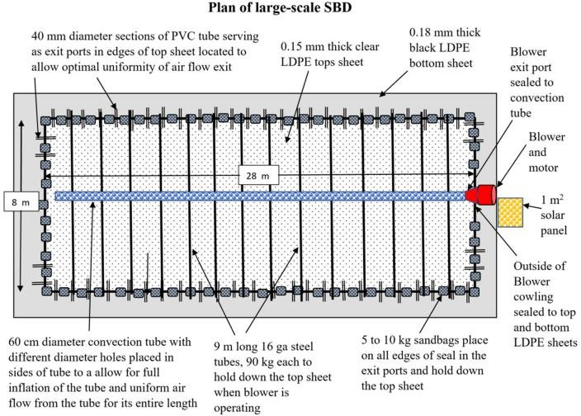

Fig 2. Diagram of large-scale SBD used in India

## Modelling of heat and mass transfer in fluidized bed dryers using the volumetric heat transfer coefficient. Part 2: calculation algorithm based on the heat and mass transfer model [5]

In the drying process using a fluidised bed , the heat transfer process was modelled. The model is used to calculate gas conditions within the environment and the thus developed algorithm was based on this model. Furthermore this helps in determining parameters such as height of the dryer and the calculation of drying time. This model obtained analysis



from the experimental data from a pilot plant. It was observed that the method of determining the logarithmic temperatures influences the values of drying parameters.

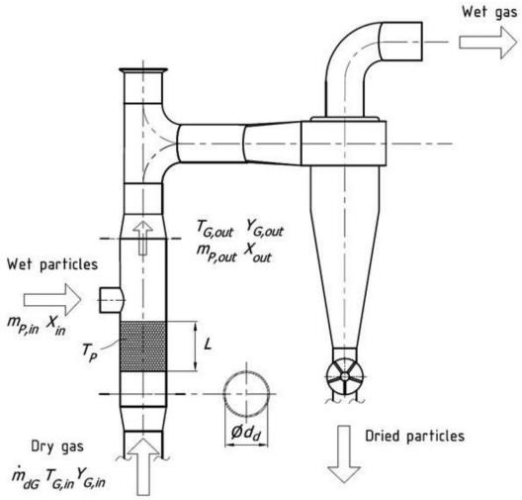

Fig 2. Schematic of the fluidized bed dryer with the cyclone dust separator



## Design Specifications

* 1. **Objective**

|  |
| --- |
| **Objectives** |
| * User friendly |
| * Automatic |
| * Cost effective |
| * Maximum drying rate |

## Constraints

|  |
| --- |
| **Constraints** |
| * Volume |
| * Temperature |
| * Capacity |
| * Quality |

* 1. **Functions**

|  |
| --- |
| * Removal of moisture |
| * Constant quality |
| * Minimum time period |

## 4.3 Generating design alternatives

**Sketch of generated design concepts/ alternatives:**

|  |
| --- |
| **Design Alternative 1** |
| * 3 different blowers at 3 different stages with varying temperatures. * Grains are passed on the conveyor belt. * Maximum moisture content from the grain is removed in the first stage,then the remaining moisture in the second and following third and then the grain without any   moisture content is collected at the bottom. |

|  |
| --- |
| **Design Alternative 2** |
| **Description**   * Automatic pressure jet oil/gas burner it helps to heat the air which enters through it * Silencer - it reduces the noise production during the process * Centrifugal hot fan - used for heating, ventilation, cooling * Grains are passed through hooper and then continued on the conveyor belt and led to dry it for some time * After that process it is passed out through outlet and collected the dried grains |

|  |
| --- |
| **Design Alternative 3** |
| **Description**   * Grains are poured by a funnel-like channel. * They will fall on the conveyor belt, which is connected by motor. * Heating element and fan are provided to remove the moisture content. * Humidity sensor is placed to check the dried grain. * Collector gathers the dried grains. |





|  |
| --- |
| **Design Alternative 4** |
| IMG20220928103054.jpg  **Description**   * Grains are fed through Funnel Shaped Area into the system. * Hot air is injected at high pressure through perforated area. * FBD bags for high moisture removal rate. * Humidified air is removed from vent. |



|  |
| --- |
| **Design Alternative 5** |
| D1.jpg  **Description**   * Here the drying air is distributed in the upper part of the drying column, with 2/3 of the column height, and the cold air (ambient air) is distributed in the lower part of the drying column, whose purpose is to remove the heat of the grain mass. * When the grains from feeder are released slowly then the drying air removed the moisture content from the grain mass then the humid air or exhaust air is released outside through ventilation. * Then fresh air from the lower part of the drying column removes the heat from grain mass & released outside the chamber. * Then Dry grains are collected from grain flow. |



* 1. **3D Model**

|  |
| --- |
| **Part Model 1** |
|  |
| **Part Model 2** |
|  |



|  |
| --- |
| **Part Model 3** |
|  |

|  |
| --- |
| **Part Model 4** |
|  |
| **Part Model 5** |
|  |

|  |
| --- |
| **Part Model 6** |
|  |
| **Part Model 7** |
|  |

|  |
| --- |
| **Part Model 6** |
|  |
| **Part Model 6** |
|  |

|  |
| --- |
| **Part Model 6** |
|  |

# Assembly models

|  |
| --- |
| **Assembly Model** |
|  |
| **Assembly Exploded View** |
|  |

## 2D Drawings

|  |
| --- |
| **2D Drawing 1** |
|  |
| **2D Drawing 2** |
|  |

|  |
| --- |
| **2D Drawing 3** |
|  |
| **2D Drawing 4** |
|  |



* 1. **Design Calculations**

|  |
| --- |
| **Design Calculations** |
|  |

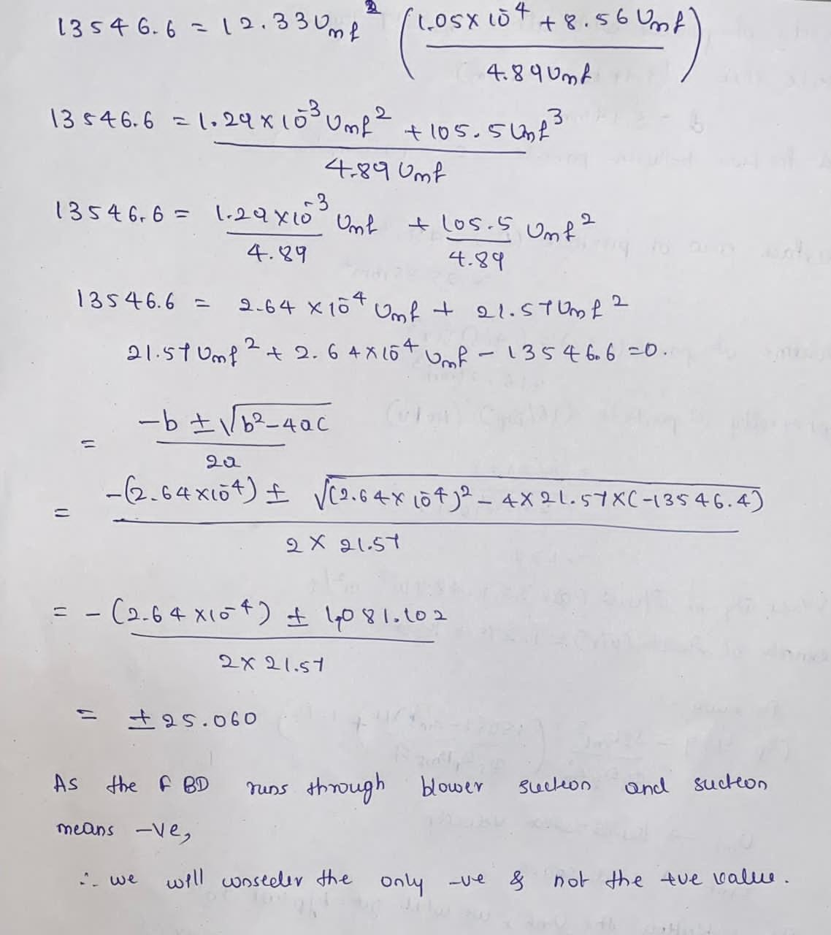



## Bill of Materials

|  |  |  |  |  |
| --- | --- | --- | --- | --- |
| **Si No** | **Part Number** | **Part Name** | **Quantity** | **Material Specification** |
| 1 | 1 | Perforated sheet | 1 | 2500mm * 4000mm Made of steel |
| 2 | 2 | Pipe 1 | 4 | Diameter of 300mm & length of 4800 mm, Made of structural steel |
| 3 | 3 | Pipe 2 | 1 | Diameter of 300mm & length of 2700mm, Made of structural steel. |
| 4 | 4 | Pipe Joint | 2 | Diameter – 300mm Made of structural steel. |
| 5 | 5 | Hot air blower | 1 | * Quiet blower 61dB. * Temperature 100 ⁰ C to 200⁰ C. * Air flow – 4700 l/min to 6000 l/min * Blower type – Radial Blower |
| 6 | 6 | Bolts | 20 | M10 |
| 7 | 7 | Nuts | 20 | M10 |
| 8 | 8 | Washers | 20 | M10 |



**Application**

We can use this prototype to remove moisture content from the grain.Grain can be easily dried and quality of grain is not compromised.With minimum cost setup,even small farm holders can have access to this prototype.

## Advantages

1. Reduction in moisture content of grain helps to avoid degradation of grain and can be even stored for a long time..
2. Risk of harmful agents such as aflatoxins which can damage the cereal , can be eliminated.
3. Grain drying reduces losses occurred while using conventional methods.
4. Use of a grain dryer results in more production and good quality.

## Structural Analysis and Mechanisms

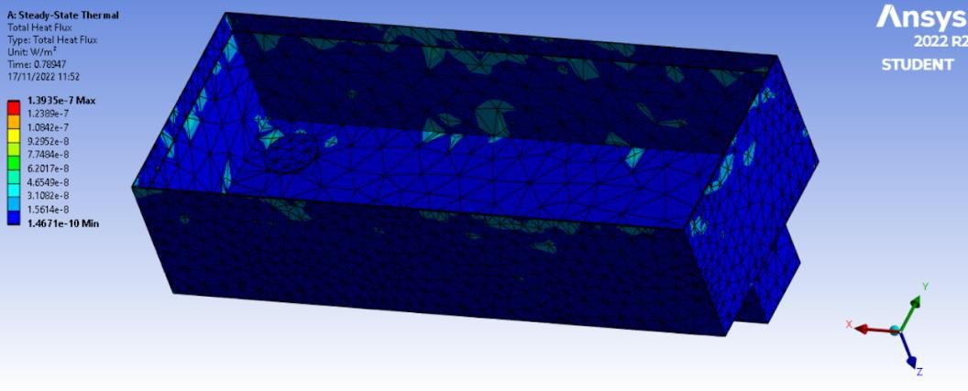

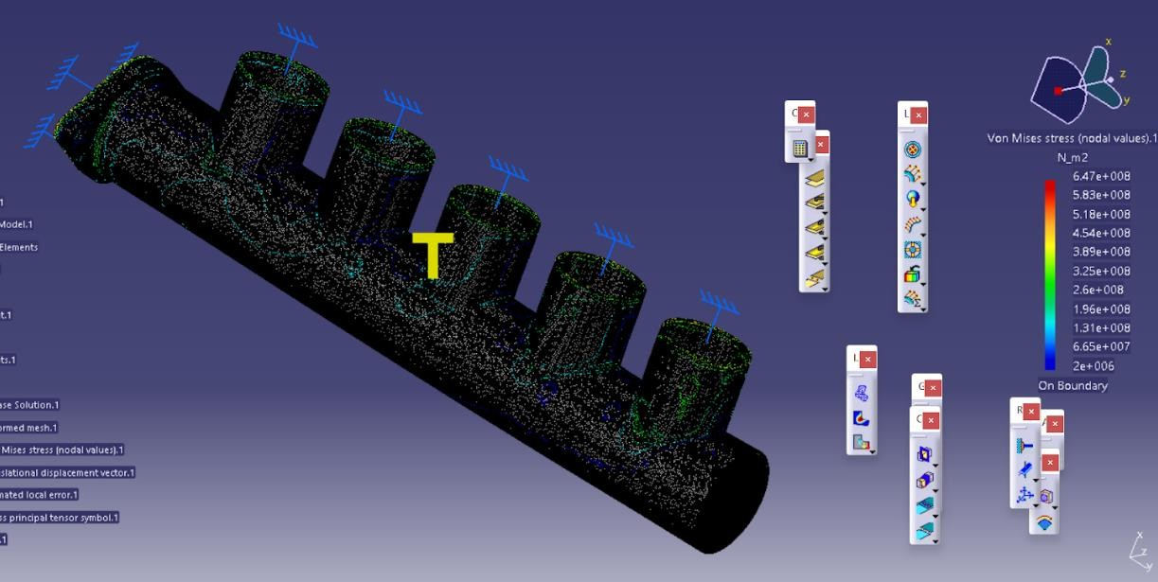

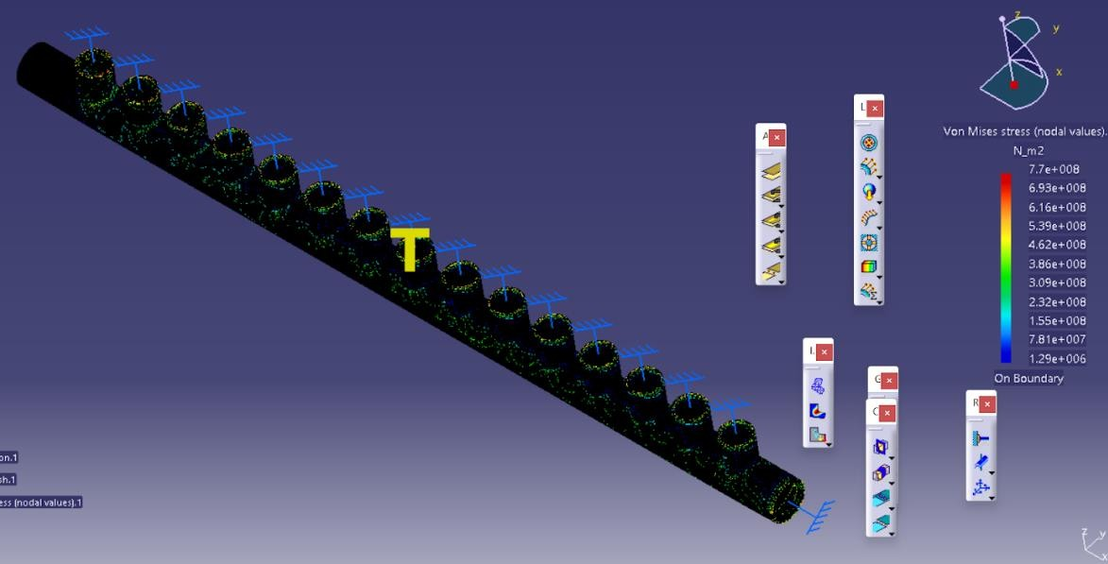

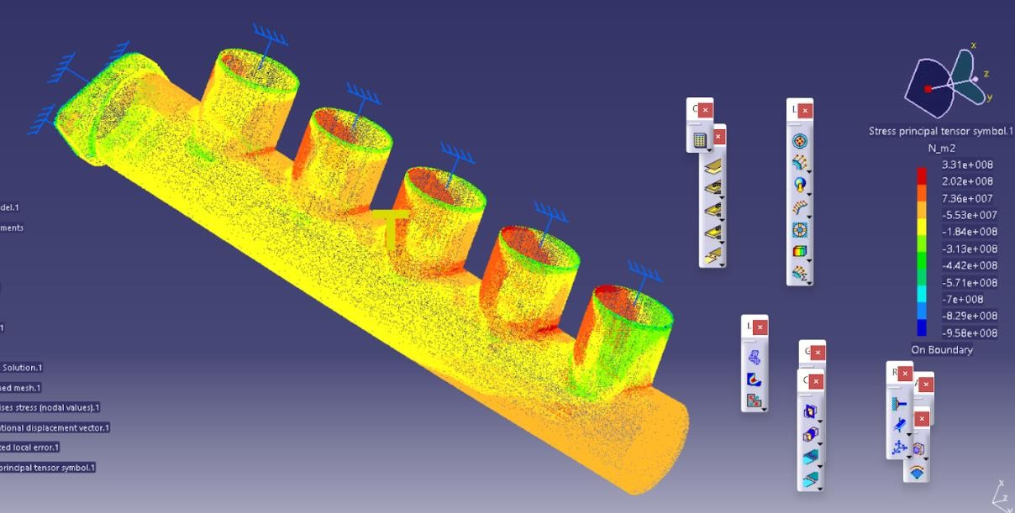

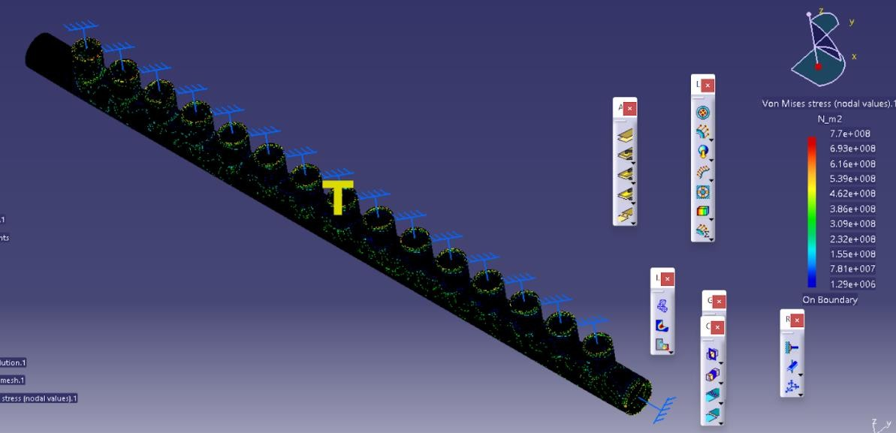

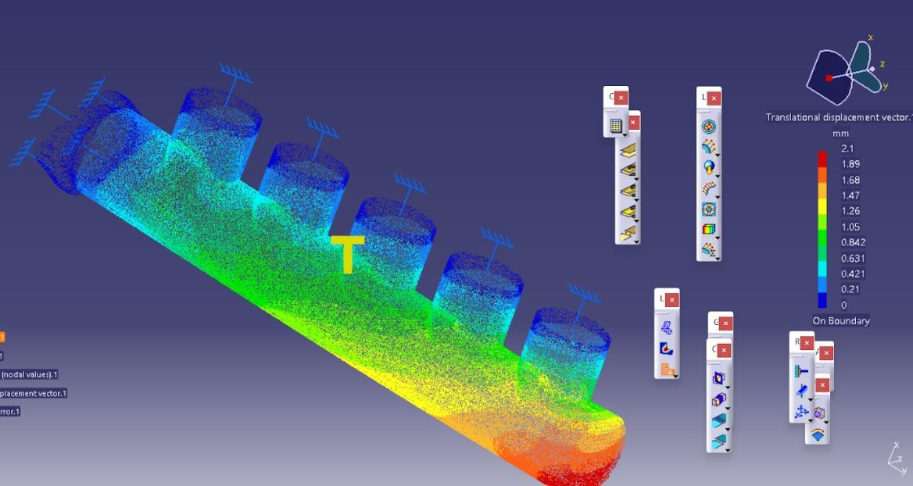

* 1. **Type of FEM Analysis and Justification**
     + The part chosen for analysis is pipes. Fem analysis chosen for this part is CFD analysis.
     + CFD analysis is basically done for a parts where fluid flows, we can solve complex problems involving fluid-fluid, fluid-solid or fluid-gas interactions.
     + The another part, which requires analysis in our model is that, grain dryer chamber.
     + As the temperature flows in chamber, static thermal analysis is chosen for to do so.

## FE Analysis Details

* + - Analysis type - CFD and Static thermal
    - Mesh type - Coarse type
    - element type - Triangular
    - element numbers - 16000-22000
    - material chosen - Structural steel

## properties

* + - young’s modulus - 210000 Mpa
    - poisson's ratio - 0.28
    - coefficient of thermal expansion – 1.2*10^-5 /⁰C

## 6.3. Results and Discussions

The grain dryer using a fluidized bed drying process optimises drying time and removes the required amount of moisture from the grain. FEM analysis shows the designed system sustains the load of the grains and the system. CFD analysis shows the movement of heat from the fluid through the system.

The system may fail when overloaded over the specified working range. Grains having chippings of wood, grass.

## Conclusions and Future Scope

This grain dryer can be automated such that grains can be cleaned off dust particles which hamper convection heat transfer. And be cleaned off wood chippings. Also can be made smart using sensors which measure moisture content, humidity within, temperature distribution using smart AI. Load cells can be used to check the distribution of grain on the bed.

## Conclusions

By the results of analysis, it's clear that solar dryer can remove most of the moisture content from grain more than the open sun drying.Time is consumed and even continuous observation like in open sun drying is not required.The quality of grain is not compromised.It is evident that the solar dryer is more beneficial than the sun drying techniques. They can be used during cloudy weather. During normal days they can work too well. The solar dryers are costly but they maintain the quality of the grains.They are rapid, safer & effective than the traditional drying techniques. The system should have maximum utilisation factor, i.e. it must be of multipurpose use to share the cost of the dryer. During the night period, it is necessary to develop a system having a backup of thermal storage. Desiccant based de-humidified hot air can be an efficient alternative solution for better drying purpose. They absorb moisture because of the difference in vapour pressure between the surface of the desiccant and the surrounding.

## Reference

[1] [Anand Chavan, Vivek Vitankar, Nikhil Shinde & Bhaskar Thorat](https://www.tandfonline.com/doi/full/10.1080/07373937.2020.1863422) Published online: 06 Jan 2021

CFD simulation of solar grain dryer: Drying Technology

[Bachir El Fil & Srinivas Garimella](https://www.tandfonline.com/doi/full/10.1080/07373937.2021.1938599) Published online: 21 Jun 2021

[2]

The state of the art in energy saving techniques for garment/textile drying

[Chao Gui, Leren Tao, Weifang Yang, Yaqi Zhang, Shanshan Chen, Daoming Shen](https://www.tandfonline.com/doi/full/10.1080/07373937.2021.1930038) Published online: 14 Jul 2021

[3]

Numerical simulation of heat and mass transfer during sublimation drying.

1. [Andrew G. Watson, Salko Aleckovic & Rajeev Nallamothu](https://www.tandfonline.com/doi/abs/10.1080/07373937.2021.1931295?journalCode=ldrt20) Published on: 09 Jun 2021

A novel and improved solar drying system appropriate for smallholder farmers: Drying Technology

1. [Viktor Szabó & Tibor Poós](https://www.tandfonline.com/doi/full/10.1080/07373937.2021.1938111) Published online: 08 Jul 2021

Modeling of heat and mass transfer in fluidized bed dryers using the volumetric heat transfer coefficient